Rental Agreement
Conrad N. Hilton Memorial Park and Community Center

Cisco, Texas

Conrad N. Hilton
Memorial Park and Community Center
Post Office Box 350 ~ 309 Conrad Hilton Avenue
Cisco, Texas 76437
(254) 442-2537 Main Office ~ (325) 998-2560 Cell
RENTAL AGREEMENT

Please read and completely understand the terms and conditions of this rental agreement prior to filling out the accompanying rental form. This is a legally binding contract.

Rental Rates for Community Room / Auditorium:
$100.00 per hour with a four (4) hour minimum.

Rental Rate for Board Room and Lobby:
$25.00 per hour with a two (2) hour minimum.

Damage / Key Deposits: (Required with all Rentals)
$250.00 normal rentals; with food, youth, reunions, etc. (Great Room)
$350.00 rentals where alcohol is consumed. (Great Room)
$50.00 regular meeting rentals (Board Room and Lobby Space)

All deposits must be paid at the time of signing of the rental agreement. The rental deposit is NOT part of the regular rental and is refundable if the integrity of the facility is acceptable after the rental event.

A $25.00 key deposit is included with the damage deposit. If the key is not retuned, this portion of your deposit will be retained by the Hilton Community Center. We apologize for having to add this extra fee. It has unfortunately become necessary because historically people fail to return the key assigned to them. The security of the Hilton is paramount. We are very conscientiously about this responsibility. It is an honor and privilege to be entrusted with the care and maintenance of this historic facility and trust you feel the same way.

RULES GOVERNING THE USE OF COMMUNITY CENTER MEETING FACILITIES

The Conrad N. Hilton Memorial Park and Community Center wishes to be a contributing factor in the community by making this facility available for community and private purposes whenever possible. However, the Center does not have the financial resources to provide free utility and janitorial services for meeting and other functions; and, as a non-profit community-based organization, the Center is accountable for the use and care of this facility. Therefore, the following rules are set forth to govern the use and care of the meeting facilities of the Community Center. If inspection reveals need for additional clean-up and or maintenance, the cost shall be included in the final amount owed for the rental. This means that you might not get your deposit back, plus you could be liable for additional charges if necessary.

The renter shall be responsible for picking up a key or obtaining a code from the Chamber Office on Friday before 4:30 p.m. Our office is not open on the weekend. The key must be returned the following Monday and final payment made for the rental hours of the Community Center. Failure to return the key will result in the forfeiture of $25.00 of the initial deposit.

- The renter shall be responsible for the facility during their rental period and shall leave the Community Room/Auditorium, kitchen area, restroom and other areas used in a neat and clean manner.

- All tables and chairs are to be returned to the arrangement in which they were found.

- All facilities shall be cleaned immediately after use, prior to leaving.

- The renter shall be financially responsible for any and all damage (associated with their use of this facility) to the facility, and its contents, during the rental period.

- No decorations or other materials are to be attached to the walls, ceilings or curtains.
- All youth activities must be supervised by responsible adults.

- Persons using the facility assume all responsibility for the caterer and caterer clean-up.

- Rental is only for the Auditorium and Kitchen facilities. The Museum, Pictorial Gallery, and upstairs facility are not open to the public without staff present.

- No rentals granted to parties where alcohol is present for children’s parties.

- The Hilton is completely a smoke free campus. There is one designated smoking area on the front porch. Please use the bird baths for residual cigarettes, butts, etc.

The Conrad N. Hilton Community Center and Memorial Park reserves the right to refuse services to perceived “hate” groups for the purpose of protesting and or rioting. We also reserve the same right to refuse services to people with an outstanding balance with us or renters who have left the facilities or grounds in an unacceptable condition in the past.

One Final Note:

You are our honored guest here at the Hilton Community Center and Memorial Park. We want you to enjoy your event and our facility to the fullest. The intent of this contract along with the rules and guidelines are just as much for your safety and security as they are to protect this historic venue.

We have been charged with an incredible responsibility for the upkeep and preservation of such an amazing part of history. We take this responsibility very seriously. Our desire is to be able to provide an enjoyable experience for many years to come.

Your assistance is greatly appreciated. Many of these new guidelines were added and or adapted because people have taken advantage of what would be considered an old gentleman’s agreement type of doing business in the past.

Dixon Seider, Executive Director / Curator

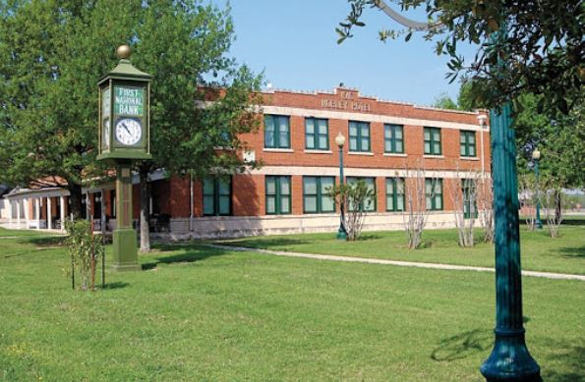
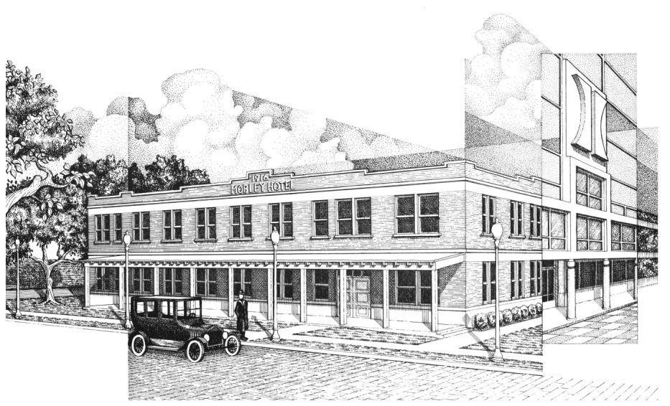
Conrad Hilton Community Center and Memorial Park

